 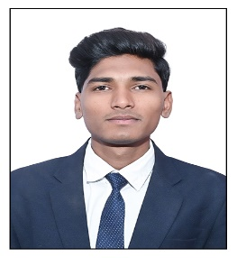

**Education**

**PGDM**

Pursuing

2023-2025

Sanjivani Institute of Management, Kopargaon.

**Bcom**

65.68%

2019-2023

Arts commerce science college, Rahata, Tal:- Rahata.

**HSC**

61.69%

2020

Sharda Vidya Mandir Rahata

**SSC**

**83/5/86+**

55%

2018

Sharda Vidya Mandir Rahata.

**Carrier Objective**

Passionate and to commitment to excellence. Looking for an opportunity to contribute my skills and dedication to dynamic team be a key player with achieving organizational goals.

+917038844415

naiddaruwale1418@gmail.com

https://www.linkedin.com/in/naid-druwale

Daruwale Naid Ansar

A/P:- Rahata

Tal:- Rahata , Dist:- Ahmednagar, Maharashtra, India

**Soft Skills**

* Learning Ability.
* Teamwork.
* Leadership Quality.
* Positive Attitude.

**Technical skills**

* Microsoft word.
* Excel.
* Power point.
* Tableau

**Language Known**

* English.
* French
* Hindi
* Marathi.
* French

**Extra-Curricular Activities**

* Complete ESGD UrFU.
* Attend CII Marketing Leadership
* Presented Paper on IEEE.
* Completed TCS Certificate Program

**Internship:**

|  |
| --- |
| **Title**: - Plant Tissue Culture. |
| **Company:** - Yuga Culture. |
| **Position**: - Lab Assistant. |
| **Duration:** - 3 Months. |
| **Brief Description: -** |
| * To understand the how tissue culture production is   carried out. |
| * To learn Practical Knowledge and experiencing   the handling of lab instruments. |

* Marathi

**Certifications**

* Data Analysis and Visualization using Excel.
* Data Analysis and visualization With Tableau.
* Excel Fundamentals for Data Analysis.
* Rubicon Soft Skill Development Training.

Date: Place: Daruwale Naid

**Hobbies**

* Travelling.
* Cricket (playing).
* Listening Music.

**Project :-**

Project Title :- *AI study on Potential of A.I in Agriculture Sectore in Indian* .

* Marathi